**DEPARTMENT P**

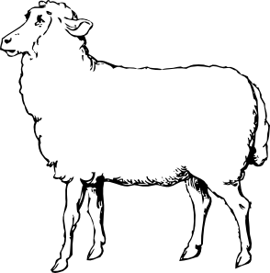

**JUNIOR MARKET LAMB SHOW**

**(Rules and Regulations)**

*Sheep will be accepted from Alexander, Burke, Caldwell, Catawba,*

*Cleveland, Gaston, Iredell, Lincoln, McDowell & Rutherford Counties Only,*

*Or active members of the Catawba Valley Youth Showmanship Circuit (704-736-8458).*

1. Junior Market Lamb Show will be held on Monday, September 2nd at 1:30 p.m. Entries must be in place by 12:30 noon.
2. Exhibitors must be 19 years of age or under as of show date.
3. Exhibitors must be residents of counties listed or an active member of the Catawba Valley Youth Showmanship circuit.
4. Lambs must be owned by the exhibitors at least 30 days before show date.
5. Lambs shown must be wethers or ewes (NO RAMS).
6. Lambs may be shown at halter. Major fitting should be done prior to arrival at Fair.
7. Lambs will be shown as individuals. Each exhibitor is limited to two entries.
8. If a junior has more than a one lamb in a class, the other lamb must be shown by a junior approved by the Show

Superintendent.

1. Class size will be determined after weigh in and classes will be broken by weight at the discretion of the Show

Superintendent.

**PREMIUM SCHEDULE**

**CLASS** 1st 2nd 3rd 4th 5th 6th

P 1 $30 $25 $20 $15 $15 $15

(P1A through P1F, as necessary, or more than 6 head entered)

P2 GRAND CHAMPION MARKET LAMB - $25.00 plus Rosette

P3 RESERVE GRAND CHAMPION MARKET LAMB - $20.00 plus Rosette

**JUNIOR MARKET LAMB SHOWMANSHIP CONTEST**

**Entries and Awards**

1. The Junior Showmanship Contest is open to all junior exhibitors who participate in the **Junior Market** **Lamb Show**.
2. Those exhibitors under 9 years of age MAY enter the Novice/Participation class if they desire. These exhibitors will not be

placed and will all receive the same premium.

1. Basis for awards will be 25% fitting and 75% showmanship.
2. To be held immediately before **Junior Market Lamb** **Show**.

**PREMIUM SCHEDULE**

**CLASS** 1st 2nd 3rd 4th 5th 6th 7th 8th

P4 (Novice/Participation class) $10 $10 $10 $10 $10 $10 $10 $10

P5 (13 years of age and under) $25 $22 $20 $18 $16 $14 $12 $10

P6 (14-19 years of age) $25 $22 $20 $18 $16 $14 $12 $10

P7 – Intermediate Champion – Rosette

P8 – Reserve Intermediate Champion – Rosette

P9 – Senior Champion – Rosette

P10 – Reserve Champion – Rosette

49

**OPEN SHEEP SHOW**

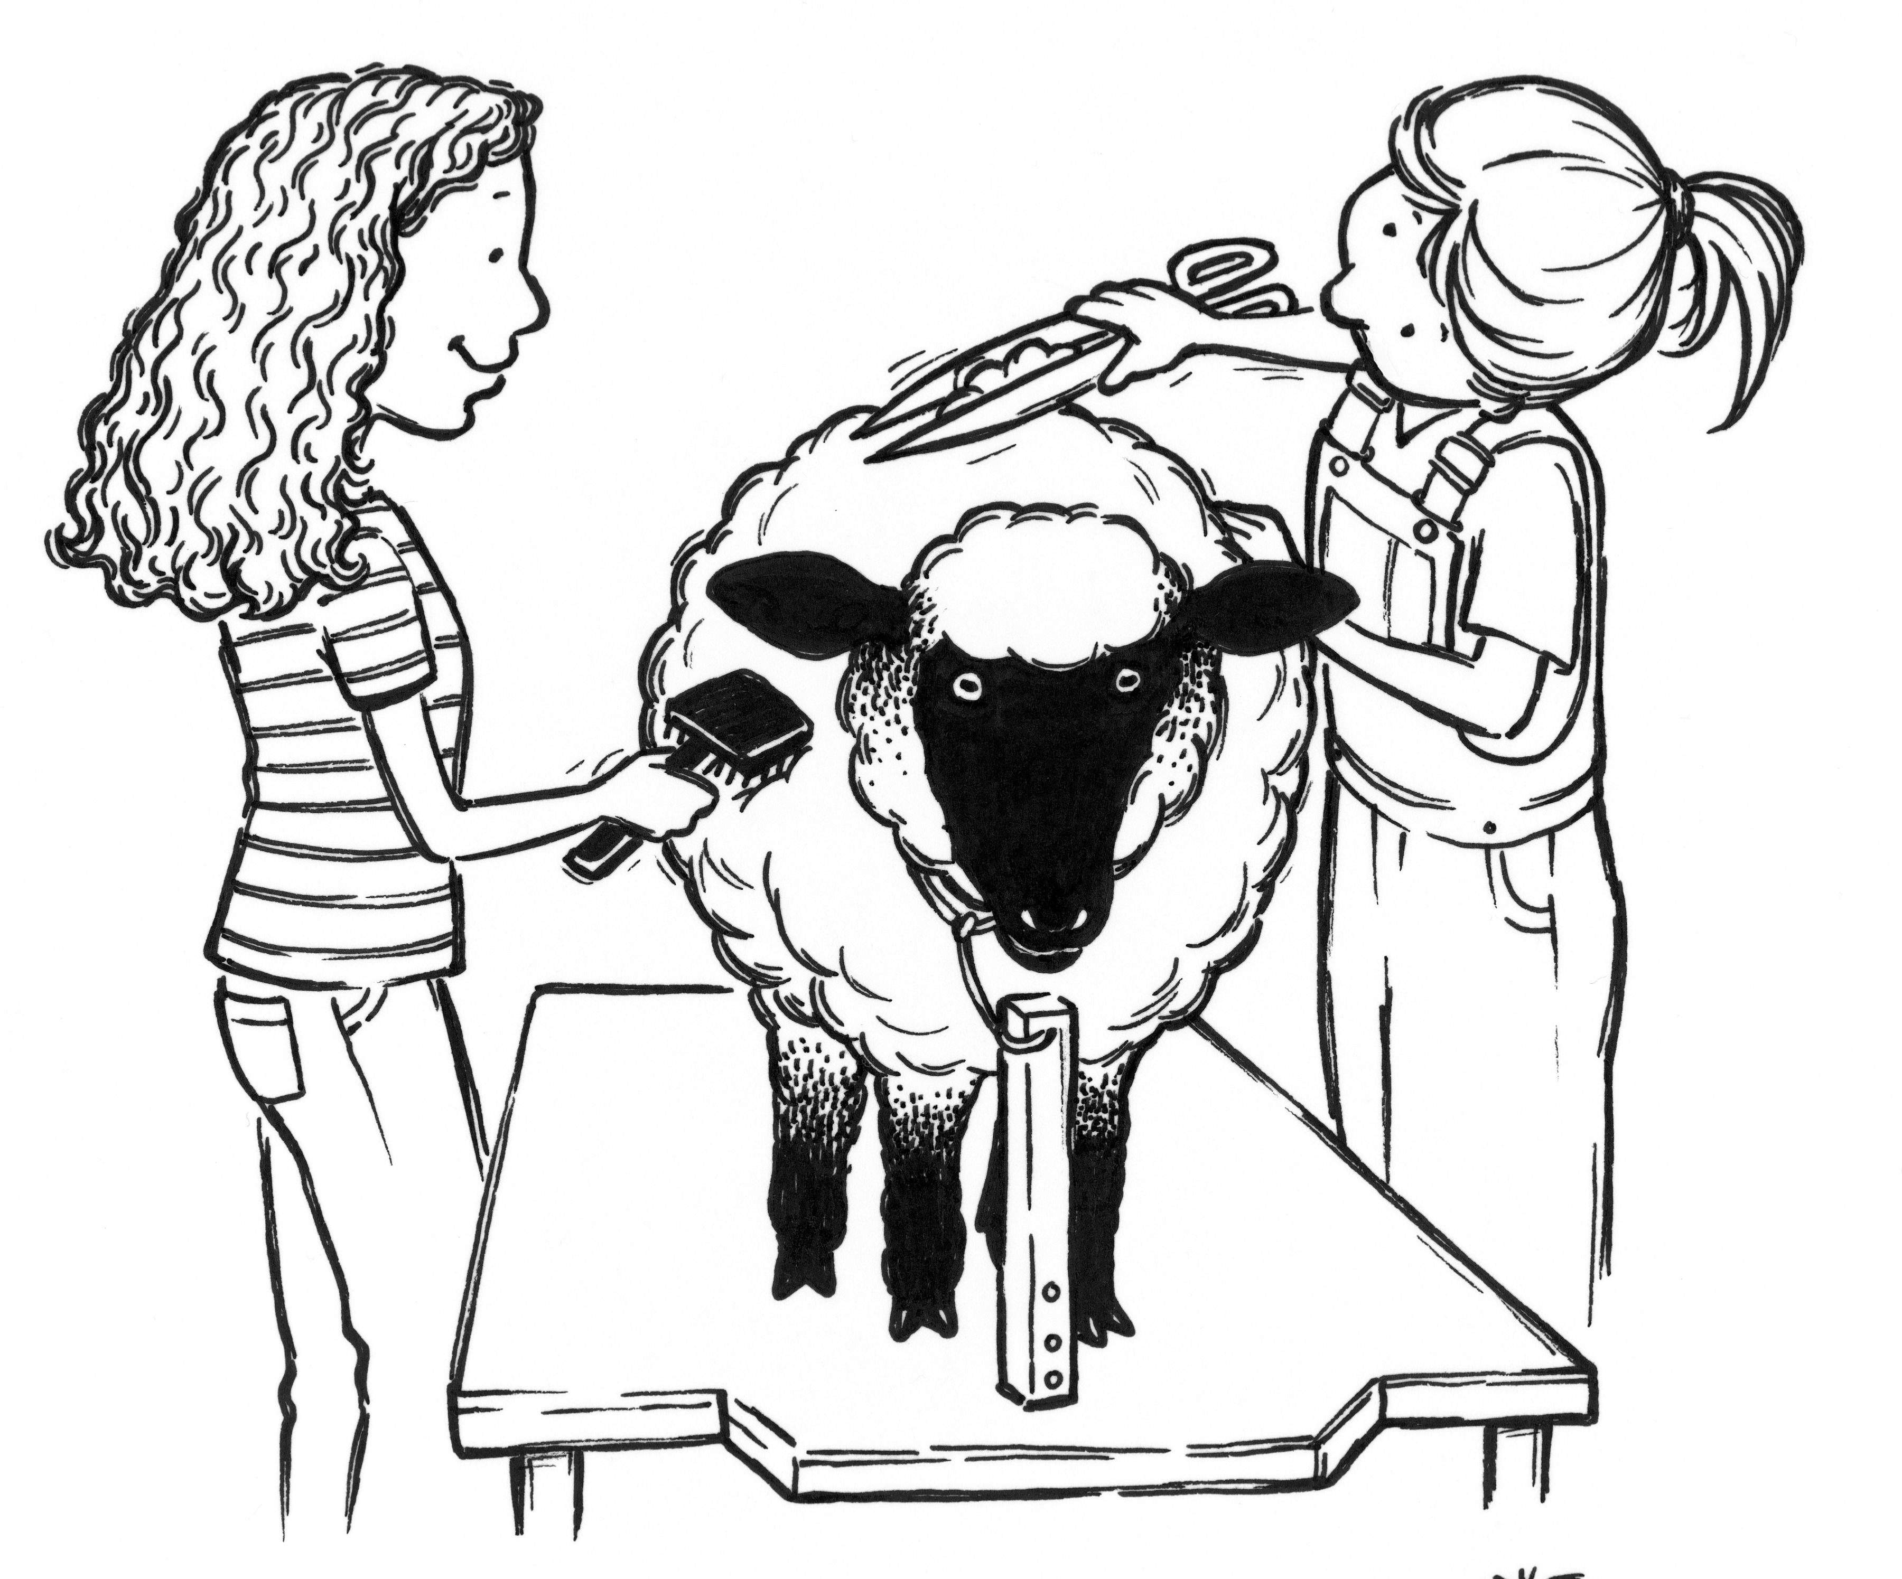

Judging Starts: Monday, September 2nd, 2019, 2:30 pm after the market lamb show.

Competition: Open to any resident of counties listed or an active member of the   
 Catawba Valley Showmanship Circuit.

Entries Close: Wednesday, August 21, 2019.

Health: See details at beginning of Department “P”.

Show Order: Suffolk, Hampshire, All Other Breeds, Commercial.

1. ALL SHEEP MUST BE CLEAN AND PROPERLY FITTED TO QUALIFY FOR ENTRY IN THIS SHOW.
2. All animals (in Purebred classes) over three months of age must be registered with their bread association in the

name of the bona fide owner, who must have owned the animal for a least 30 days prior to August 31, 2018.

1. Each exhibitor is limited to two entries per class.
2. Exhibitor must be at least (9) years of age on show date.
3. Superintendent reserves the right to limit entries according to barn space. Make your entries early.

Junior Ram Lamb – born after 12/31/18 P100 P120 P140 P160

Yearling Ram Lamb – born 9/1/17 to 12/31/18 P101 P121 P141 P161

Champion Junior Ram P102 P122 P142 P162

Reserve Champion Junior Ram P103 P123 P143 P163

Ram, 1 yr. – under 2, born after 9/1/17 before 9/1/18 P104 P124 P144 P164

Ram, 2 and over – born before 9/1/17 P105 P125 P145 P165

Champion Senior Ram P106 P126 P146 P166

Reserve Champion Senior Ram P107 P127 P147 P167

Grand Champion Ram P108 P128 P148 P168

Reserve Grand Champion Ram P109 P129 P149 P169

Junior Ewe Lamb – born after 12/31/18 P110 P130 P150 P170

Yearling Ewe Lamb – born 9/1/18 to 12/31/18 P111 P131 P151 P171

Champion Junior Ewe P112 P132 P152 P172

Reserve Champion Junior Ewe P113 P133 P153 P173

Ewe, 1 yr. – under 2, born after 9/1/17 before 9/1/18 P114 P134 P154 P174

Ewe, 2 and over – born before 9/1/17 P115 P135 P155 P175

Champion Senior Ewe P116 P136 P156 P176

Reserve Champion Senior Ewe P117 P137 P157 P177

Grand Champion Ewe P118 P138 P158 P178

Reserve Grand Champion Ewe P119 P139 P159 P179

**PREMIUM SCHEDULE** Class Placing - Ribbons

1st 2nd 3rd 4th 5th 6th 7th 8th Champions – Rosette

$30 $25 $20 $15 $15 $15 $15 $15 Grand champions - $25.00 and Rosette

Reserve Grand Champions - $20.00 and Rosette

**Costume Class**

Any exhibitor in the Junior show may participate. The exhibitor may have the assistance of one other junior age person while in the ring. Exhibitors may use any ideas they wish on how to "dress" or "decorate" their sheep to represent any personality, place or thing. Costumes may consist of any material as long as it is not considered harmful to the animal or potentially harmful to other exhibitors. Presence in the show ring constitutes entry in the class. Judging will be based on creativity and attractiveness.

**Class Premium Schedule 1st 2nd 3rd 4th 5th**

P200 Novice (under 9 years of age) $10 $10 $10 $10 $10

P201 (11 years and under) $25 $22 $20 $18 $16

P202 (12-14 years of age) $25 $22 $20 $18 $16

P203 (15-19 years of age) $25 $22 $20 $18 $16

50