Department M
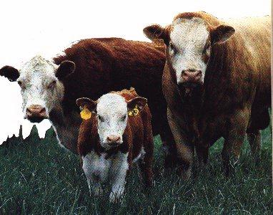

OPEN BEEF CATTLE SHOW

Information for Open Show Beef Cattle Exhibitors:

- Competition: Open to any exhibitor in Caldwell, Catawba, Burke, Alexander, Cleveland, Lincoln, Iredell and Gaston Counties only, or an active member of the Catawba Valley Youth Showmanship Circuit (704-736-8458). Any animal entered in both the Open & Jr. Shows must be entered under the name of the same exhibitor in both shows.
- Entries Close: Wednesday, August 21, 2019. NO FAXED ENTRIES WILL BE ACCEPTED. ENTER BY MAIL ONLY.
- Health: Livestock may be inspected prior to unloading.
- Cattle Receiving Times: All day Thursday and Friday until dusk, or Saturday from 6:30am to 11:00am. Stall assignments will be made in the order entries received. Entries will be capped when the barn is full and late entries will be returned. The Barn Superintendent reserves the right to limit entries.
- Cattle Must Be in Place By: Noon on Saturday.
- Judging Starts: Saturday August 31st, 2019 at 5:00pm
- Show Order:(1) Angus, (2) Charolais, (3) Commercial, (4) Hereford, (5) Shorthorn, (6) Simmental, (7) AOB
- Release of Exhibits: Barn Superintendent will grant release time. PREMIUMS WILL BE FORFEITED IF ANIMALS ARE REMOVED PRIOR TO PERMISSION FROM BARN SUPERINTENDENT.

NOTE: A few selected Open Show Beef Cattle entries MAY be asked to remain in the barn for the entire week for exhibition purposes. However, the need for this may not arise, depending on barn space.
NOTE: Exhibitors must have the original registration certificate on each animal available for inspection at the show.

PREMIUM SCHEDULE

Calf, Junior and Senior Champions $20.00 and Ribbon 1st 2nd 3rd 4th 5th

Reserve Grand Champions - $25 and Rosette $40 $35 $30 $25 $20

Grand Champions - $30 and Rosette

M101 – M131 – Angus Classes

M136 – M166 – Polled Hereford Classes

M171 – M201 - Charolais Classes

M206 – M236 – Simmental Classes

M266 – M296 – AOB

M301 – M331 – Commercial Classes

M336 – M366 – Shorthorn

(Not listed in order of show)

(Note #7 above for order)

43

